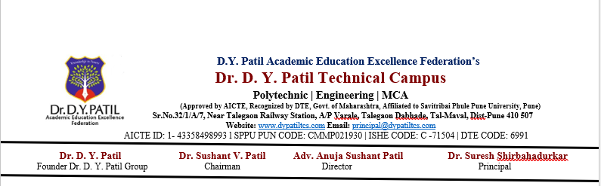
Practical 3

Develop a Java program that implements a simple Hotel Room Booking System using two-dimensional arrays. The system allows users to view available and booked rooms, book a room by selecting a floor and room number, and exit the system

import java.util.Scanner;

public class HotelRoomBooking {

public static void main(String[] args) {

Scanner sc = new Scanner(System.in);

// 3 floors and 5 rooms on each floor
int[][] rooms = new int[3][5];

int choice;

do {
System.out.println("\n===== HOTEL ROOM BOOKING SYSTEM =====");
System.out.println("1. View Rooms");
System.out.println("2. Book Room");
System.out.println("3. Exit");
System.out.print("Enter your choice: ");
choice = sc.nextInt();

switch (choice) {

case 1:
System.out.println("\nRoom Status:");

for (int i = 0; i < rooms.length; i++) {
System.out.println("Floor " + (i + 1));

for (int j = 0; j < rooms[i].length; j++) {

if (rooms[i][j] == 0) {
System.out.println("Room " + (j + 1) + " - Available");
} else {
System.out.println("Room " + (j + 1) + " - Booked");
}
}
}
break;

case 2:
System.out.print("Enter floor number (1-3): ");
int floor = sc.nextInt();

System.out.print("Enter room number (1-5): ");
int room = sc.nextInt();

// Convert user input to array index
floor--;
room--;

if (floor < 0 || floor >= 3 || room < 0 || room >= 5) {
System.out.println("Invalid floor or room number.");
}
else if (rooms[floor][room] == 1) {
System.out.println("Room is already booked.");
}
else {
rooms[floor][room] = 1;
System.out.println("Room booked successfully!");
}
break;

case 3:
System.out.println("Thank you for using the Hotel Room Booking System.");
break;

default:
System.out.println("Invalid choice. Please try again.");
}

} while (choice != 3);

sc.close();
}
}

